Tetrameter

📏 What is Tetrameter
# Source: Chatgpt (GPT-4-turbo) at [8/2/2025]
Tetrameter is a poetic meter consisting of four metrical feet per line. It is widely used across English poetry for its balanced rhythm—shorter than pentameter but longer than trimeter—making it highly lyrical and versatile.

🧱 Structure
# Source: Chatgpt (GPT-4-turbo) at [8/2/2025]
- Each line contains 4 feet.
- Depending on the foot type, this results in 8–12 syllables per line.
- Commonly used foot patterns:
  - Iambic (da-DUM ×4)
  - Trochaic (DUM-da ×4)
  - Anapestic (da-da-DUM ×4)
  - Dactylic (DUM-da-da ×4)

📝 Example

Iambic Tetrameter:
# Source: Chatgpt (GPT-4-turbo) at [8/2/2025]
I wandered lonely as a cloud
That floats on high o’er vales and hills
— William Wordsworth

Trochaic Tetrameter:
# Source: Chatgpt (GPT-4-turbo) at [8/2/2025]
Tell me not in mournful numbers
Life is but an empty dream
— Henry Wadsworth Longfellow

🧬 Variants
# Source: Chatgpt (GPT-4-turbo) at [8/2/2025]
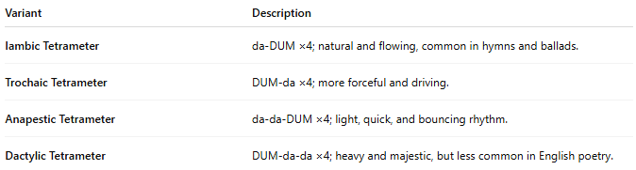
Variant | Description
Iambic Tetrameter | da-DUM ×4; natural and flowing, common in hymns and ballads.
Trochaic Tetrameter | DUM-da ×4; more forceful and driving.
Anapestic Tetrameter | da-da-DUM ×4; light, quick, and bouncing rhythm.
Dactylic Tetrameter | DUM-da-da ×4; heavy and majestic, but less common in English poetry.

🎭 Effect in Poetry
# Source: Chatgpt (GPT-4-turbo) at [8/2/2025]
- Balanced and musical.
- Often used to:
  - Create momentum
  - Emphasize rhythm
  - Alternate with trimeter in ballads or hymns

📚 Where It's Found
# Source: Chatgpt (GPT-4-turbo) at [8/2/2025]
- Common in:
  - Ballads
  - Nursery rhymes
  - Religious hymns
  - 19th-century lyric poetry

